EXERCISE NO. :7

CLOSED LOOP PNEUMATICS

THREE STEP ACTION CONTROLLER

DATE:

Reg. No. :

**PREREQUISITE KNOWLEDGE:**

* Fundamentals of pneumatics and its basic components.
* Fundamentals of FluidSIM software for simulation of pneumatic and electrical circuits.

**OBJECTIVES:**

* + To be able to explain the mode of operation of a three step-action controller
  + To be able to commission a three step action controller.

**THEORY:**

**Closed Loop Control System**

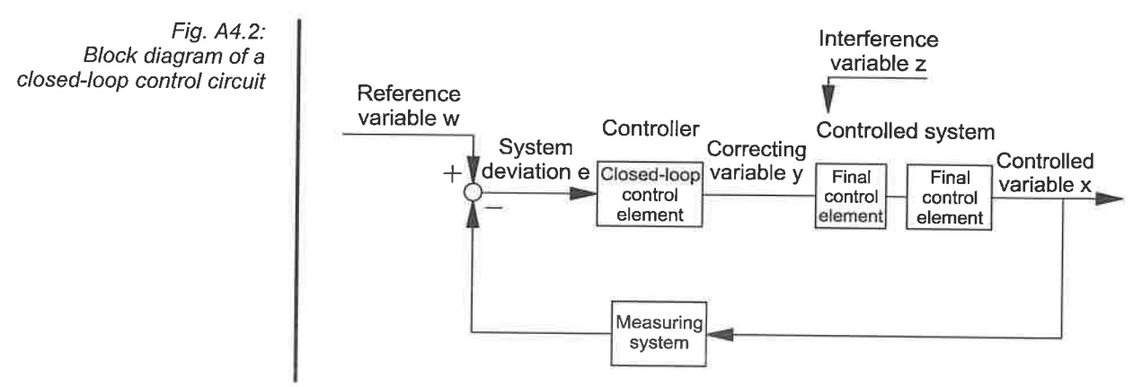

**Comparator**

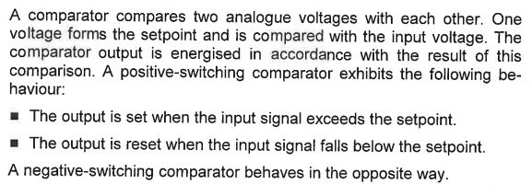

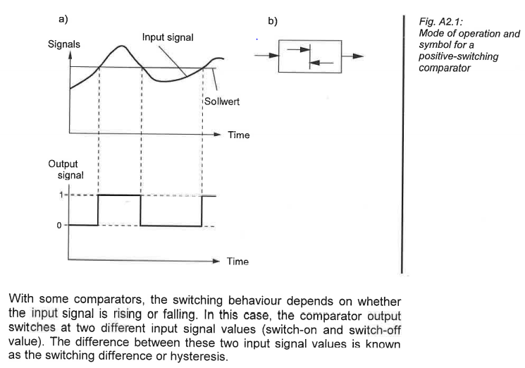

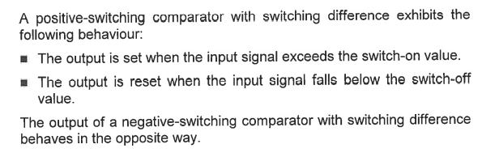

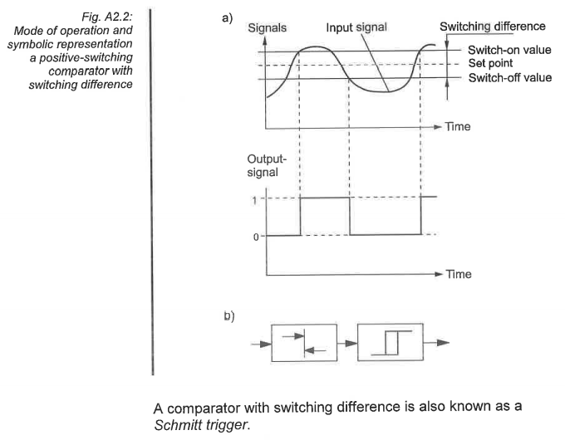

**Festo Comparator Card**

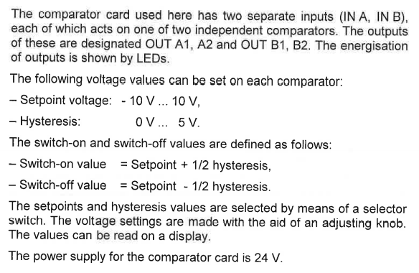

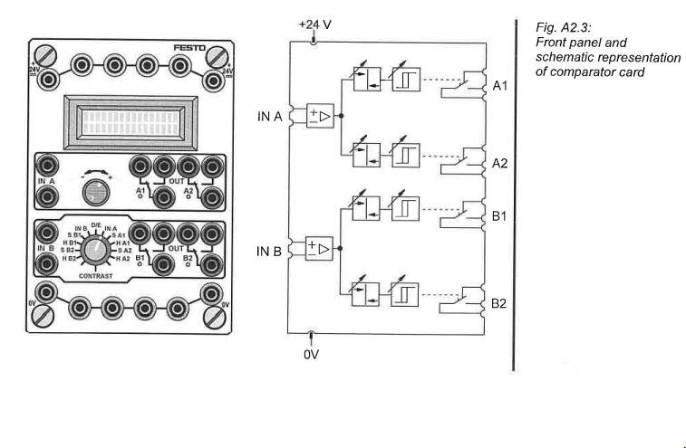

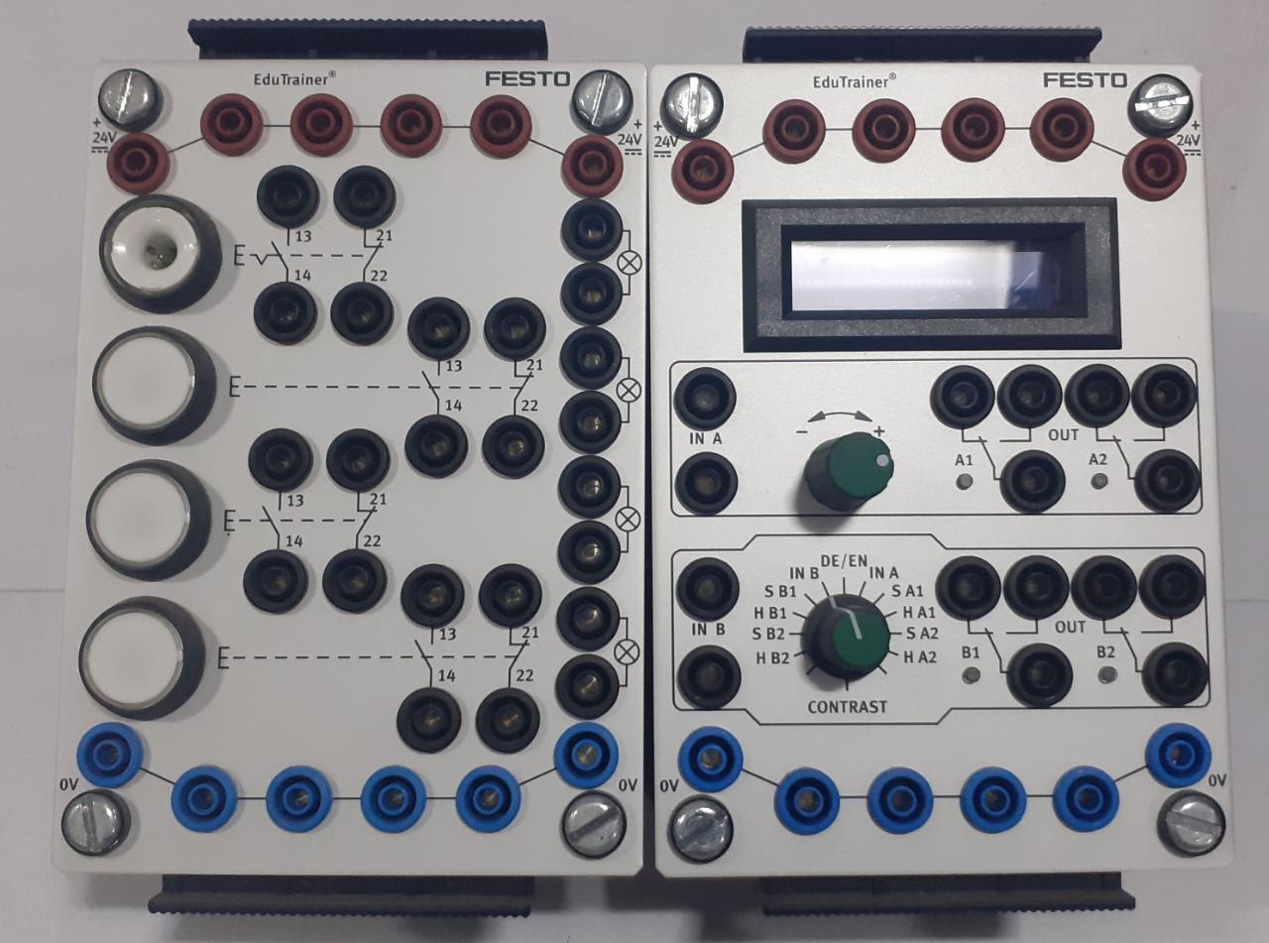

**Festo Input Module and Comparator Module**

**Three-step Action Controller**

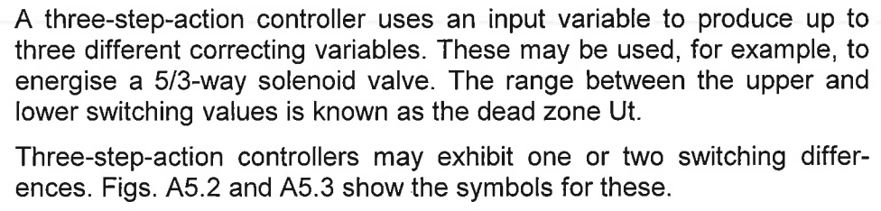

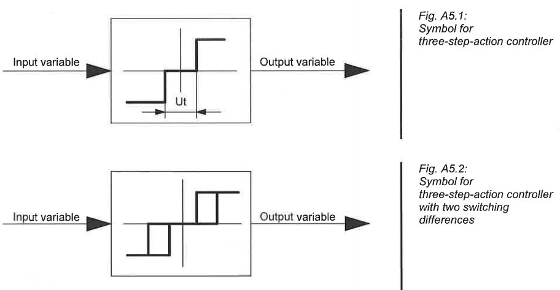

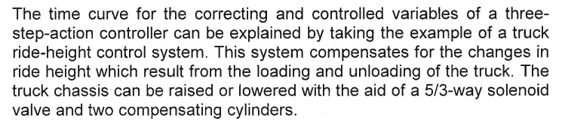

**TASK 1 – TYRE PRESSURE COMPENSATION SYSTEM**

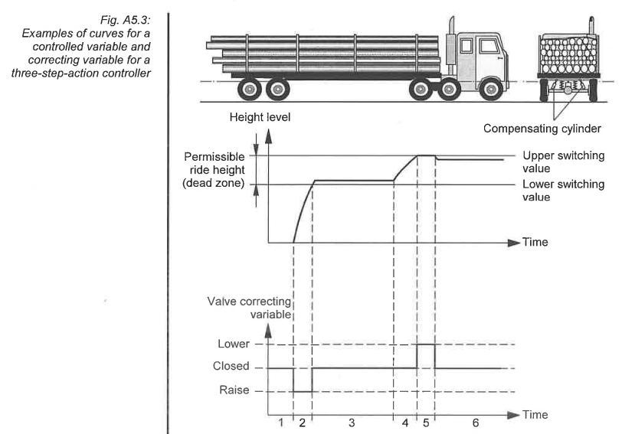

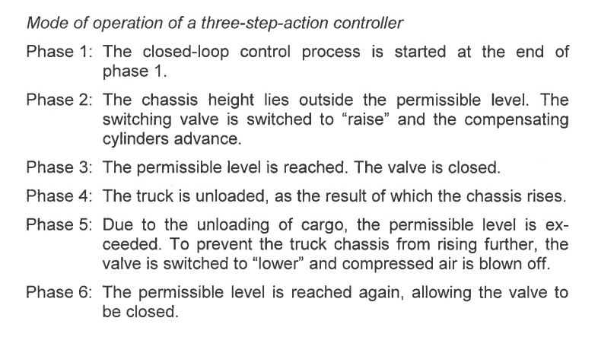

**Drafting of Closed Loop Circuit**

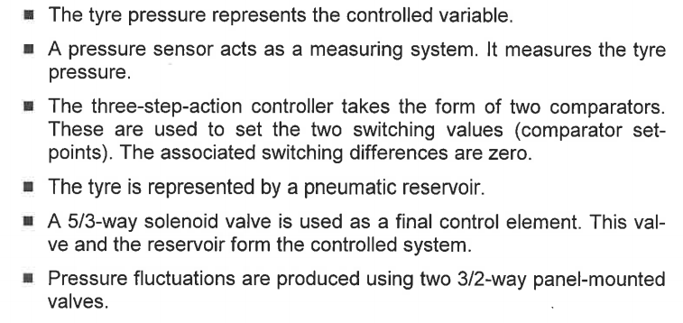

**Assembly of Three-Stage Action Controller**

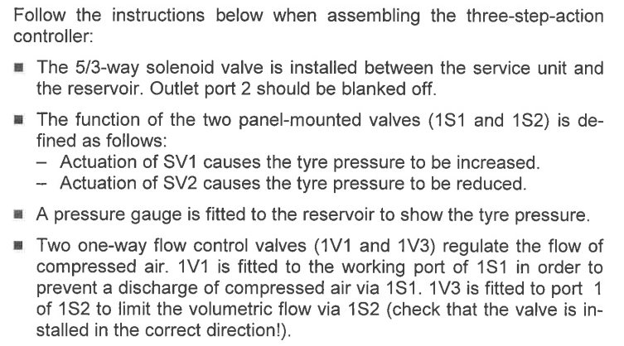

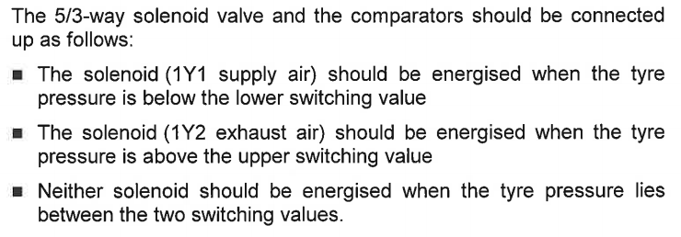

**Commissioning of Three-Step Action Controller**

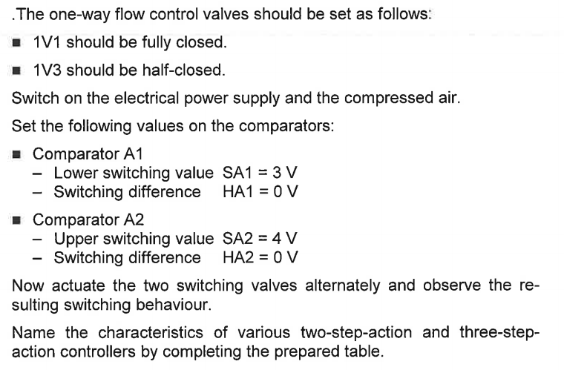

**DELIVERABLES**

**TASK 1**

* Filling up of closed loop control block diagram with Figure A4.2 as reference.

Disturbance

(over/under pressure)

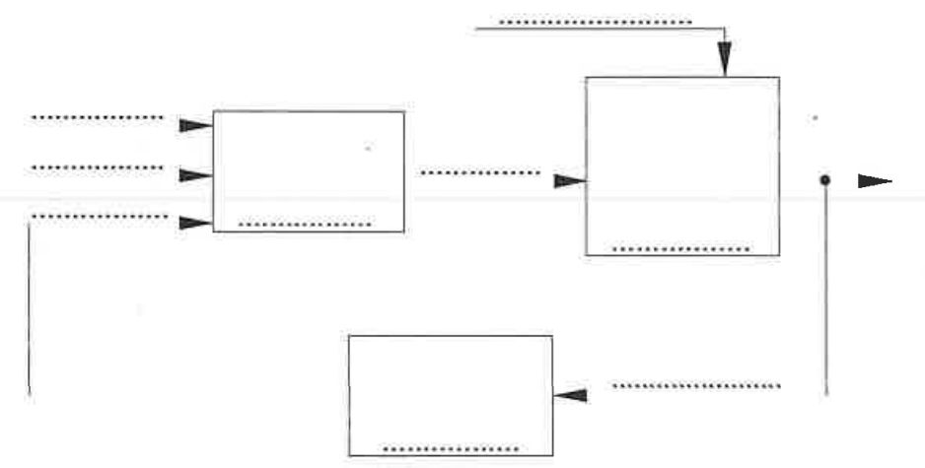

Lower Threshold

Upper Threshold

**Comparator Unit**

**Pressure Sensor**

**Solenoid Operated Spring Centred 5/3 Directional Control Valve**

Accumulator

Electrical Signal

Pressure

Pressure Value

* Pneumatic and Electrical circuit diagrams
* State diagram of the Pressure Sensor and Switching Position of the 5/3 solenoid valve for the various possible cases applicable for a three-step action controller.

**Pneumatic Circuit Diagram:**

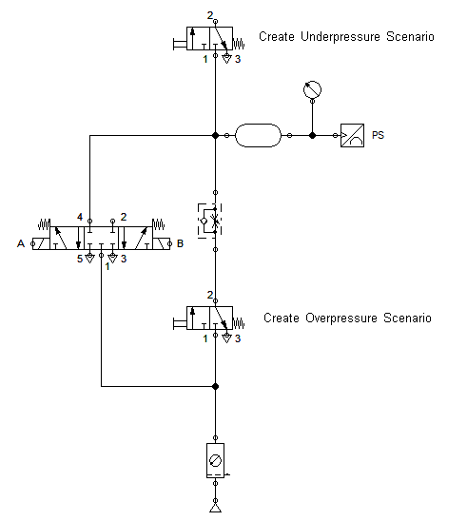

**Electrical Circuit Diagram:**

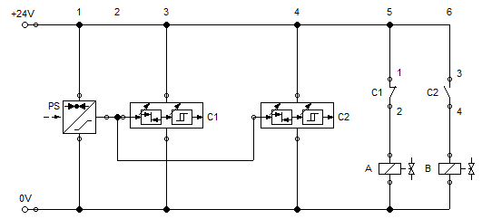

**State Diagram:**

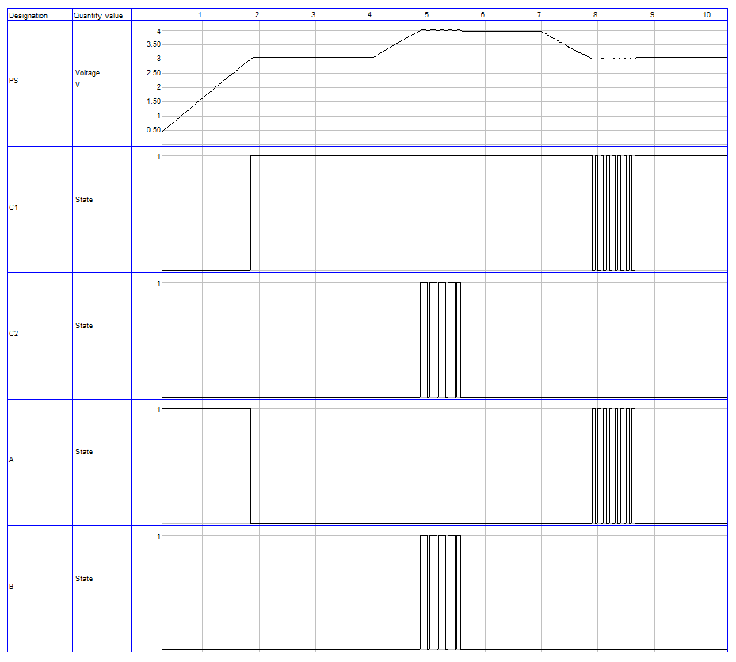

**Lab Session Screenshot:**

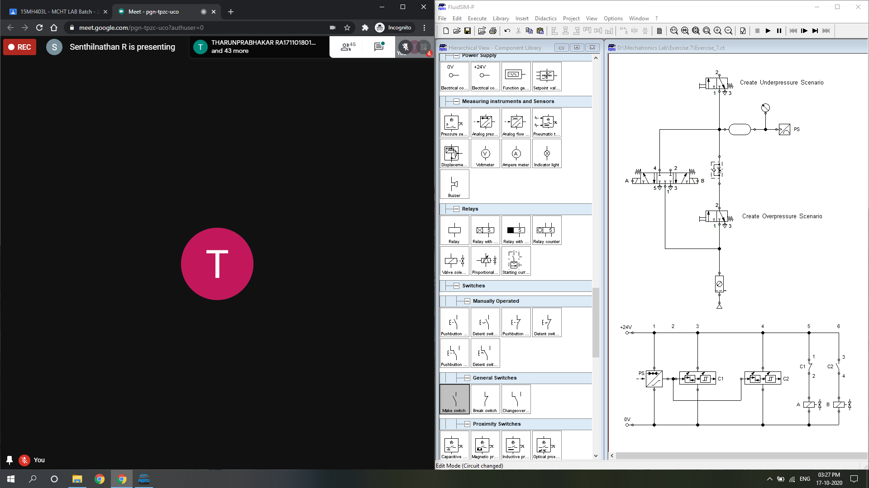

**Inference:**

This experiment was an introduction to closed loop pneumatics. Festo FluidSIM was used to simulate a closed loop pneumatic system wherein the main task was to maintain the air pressure within an accumulator within the specified bounds. The bounds were specified as upper and lower limits (dead band) which makes the system respond only outside the specified thresholds (as opposed to single threshold/limiting value for pressure which starts responding as soon as the process variable is disturbed from its setpoint).

This technique of introducing a dead band within the controller is extremely useful for practical implementation of such systems as it significantly reduces wearing of the actuating components due to rapid oscillations/switching.